**Video Games Sales Visualization**

Link to the dataset: <https://www.kaggle.com/datasets/gregorut/videogamesales>

Link to my code: <https://drive.google.com/file/d/1SntoXaIq29hpgWghAJ6TEB-sIonc0D-K/view?usp=sharing>

**The Original Graph**

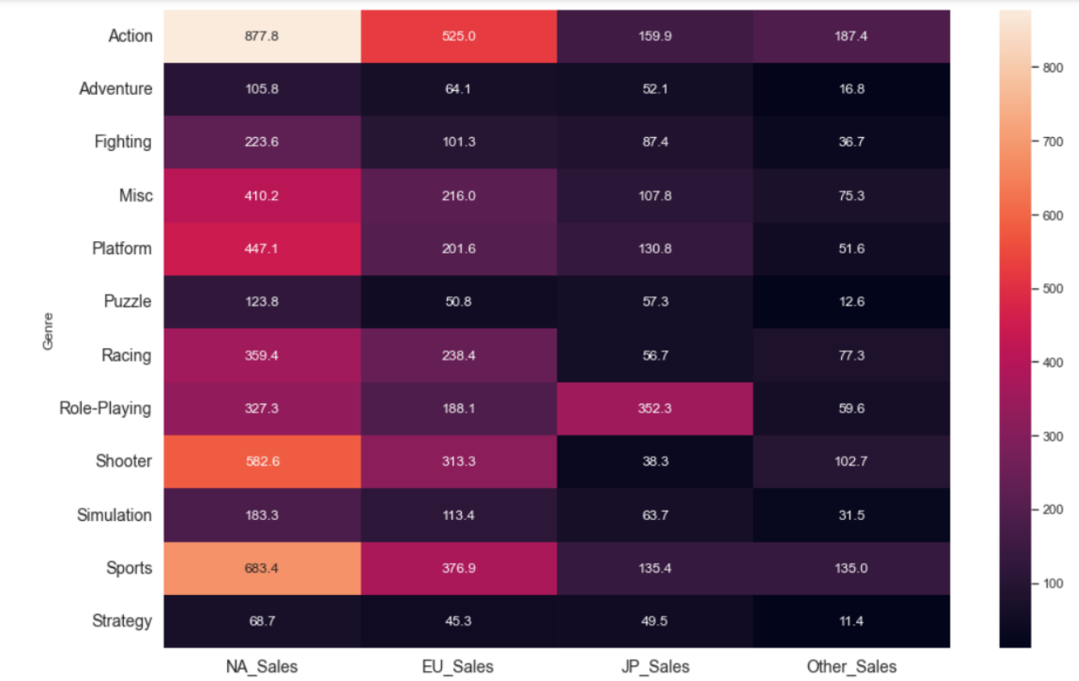

The x-axis represents video game sales in different region including NA (North

America), EU (Europe), JP (Japan), and other (rest of the world). The y-axis represents

different game genres including action, adventure, fighting, misc, platform, puzzle, racing,

role-playing, shooter, simulation, sports, and strategy. Each cell shows the number of sales

of certain genre of game in a certain region in millions. For example, the cell on the top left

shows that Action games has 877.8 million sales in North America. The color of each cell

indicates the level of sales, with lighter colors indicating higher sales and darker colors

indicating lower sales.

**New Visualization Graph**

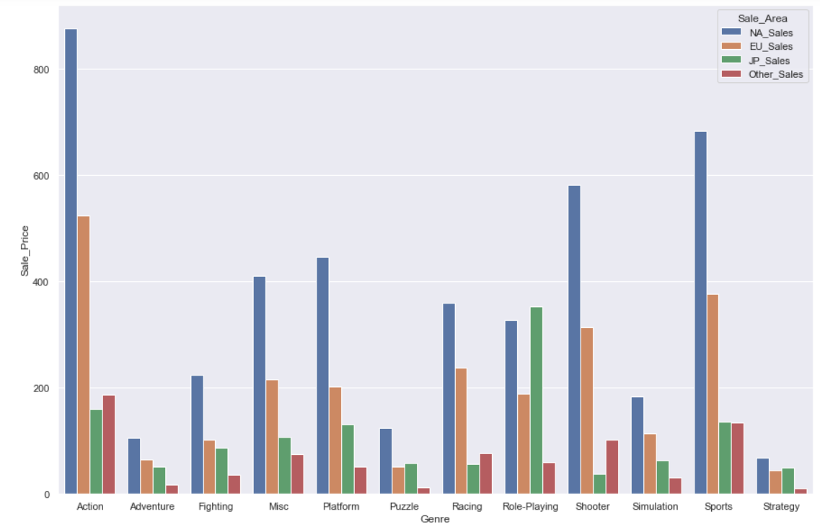

The x-axis represents different game genres including action, adventure, fighting, misc, platform, puzzle, racing, role-playing, shooter, simulation, sports, and strategy. The y-axis represents the sale number of video games in millions. Each bar represents different regions. The blue bar represents North America, the orange bar represents Europe, the green bar represents Japan, the red bar represents all other regions in the world. For example, the leftmost bar shows that North America has more than 800 million sales on the genre of action game. The second to the left bar shows that Europe has more than 500 million sales on the genre of action game.

**Findings:**

* The highest total sale of video games is action game, especially in North America and Europe region.
* Japan has a particularly high sale of role-playing game, which has a relatively low sale in other regions.
* Strategy, adventure, and puzzle games are the three least popular game genre worldwide.
* Shooter games are pretty popular in North America, Europe, and other regions, but it is the least popular game genre in Japan.

**Data and Method Text**

I visualize the video game sales data with bar chart. The reason I choose to use bar chart because the bar chart best provides a visual representation of video game sales by region and genre. It is easy to compare the sales numbers across different regions and game genres, and also highlight the regions with the highest and lowest sales for each genre, which reveals trends and patterns of video game sales in different region, such as which genre is most popular in a certain region.

**Significance**

This bar chart provides insights of market demand and preference for video game genres in different regions, which can help the game developer and publisher on game development, localization and market strategies. It also provides competitive intelligence, as it can reveal which genre is performing well in certain region and provide insights on how companies compare to their competitors in terms of sales within specific genres.